Practical: 2 | Implementation and Time analysis of linear and binary search algorithm
07/08/2026

Aim: To Implement Linear search and binary search and Time analysis their algorithms.

Algorithm:
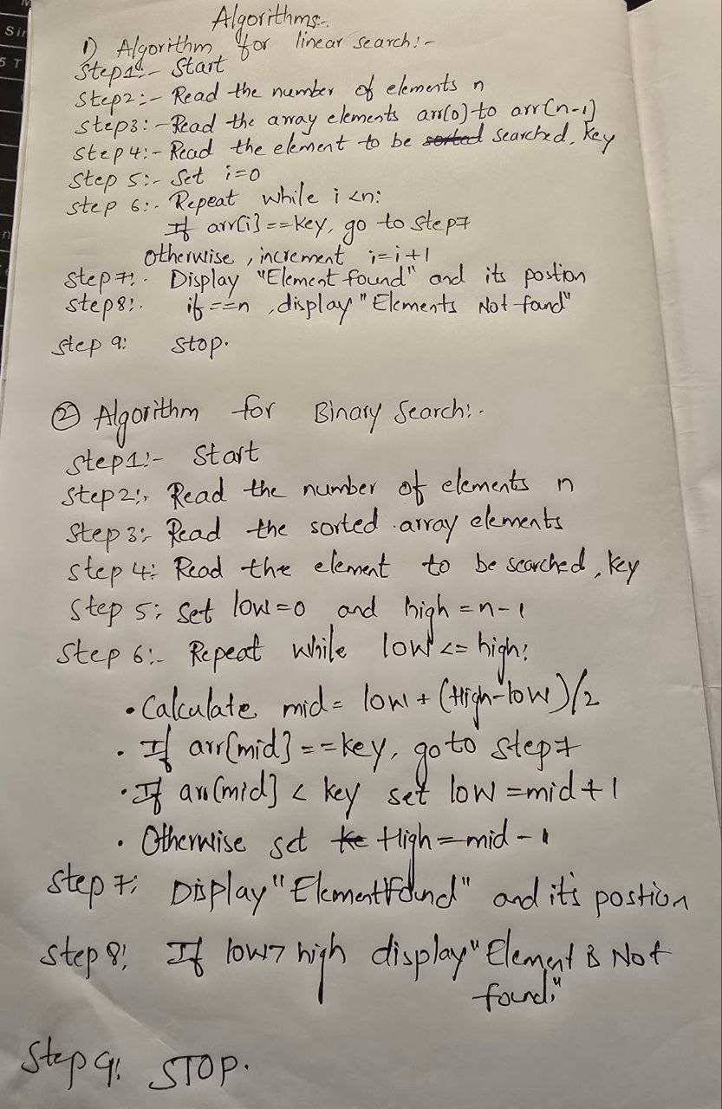

Program:

#include <iostream>
#include <algorithm>
using namespace std;

// Linear Search
int linearSearch(int arr[], int n, int key)
{
for (int i = 0; i < n; i++)
{
if (arr[i] == key)
return i;
}

return -1;
}

// Binary Search
int binarySearch(int arr[], int n, int key)
{
int low = 0;
int high = n - 1;

while (low <= high)
{
int mid = low + (high - low) / 2;

if (arr[mid] == key)
return mid;

else if (arr[mid] < key)
low = mid + 1;

else
high = mid - 1;
}

return -1;
}

int main()
{
int n, key;

cout << "Enter number of elements: ";
cin >> n;

int arr[n];

cout << "Enter elements: ";
for (int i = 0; i < n; i++)
cin >> arr[i];

cout << "Enter element to search: ";
cin >> key;

// Linear Search
int linearResult = linearSearch(arr, n, key);

if (linearResult != -1)
cout << "Linear Search: Element found at index "
<< linearResult << endl;
else
cout << "Linear Search: Element not found" << endl;

// Sort array for Binary Search
sort(arr, arr + n);

cout << "Sorted array: ";
for (int i = 0; i < n; i++)
cout << arr[i] << " ";

cout << endl;

// Binary Search
int binaryResult = binarySearch(arr, n, key);

if (binaryResult != -1)
cout << "Binary Search: Element found at index "
<< binaryResult << endl;
else
cout << "Binary Search: Element not found" << endl;

return 0;
}

Output:

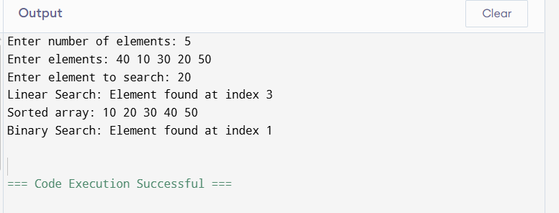

Time Complexity:

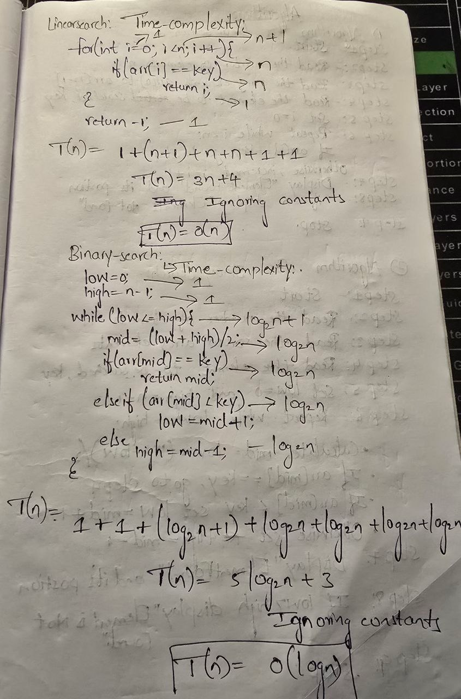

Conclusion:

From this implementation, I understood that the searching method depends on the type of data. Linear Search is simple and checks elements one by one, while Binary Search is faster because it repeatedly divides the sorted array into halves.

